# **Ori and the Blind Forest - Mechanics**

**Gameplay**

* custom game progress save
* when the player dies, they go back to where they previously saved the game

**Level design**

* tricky platforming sections
  + hanging platforms that require double jumping and wall jumping
  + enemies that have to be killed
  + thorn bushes that deal damage on touch
  + portals to navigate through the level
* puzzle solving

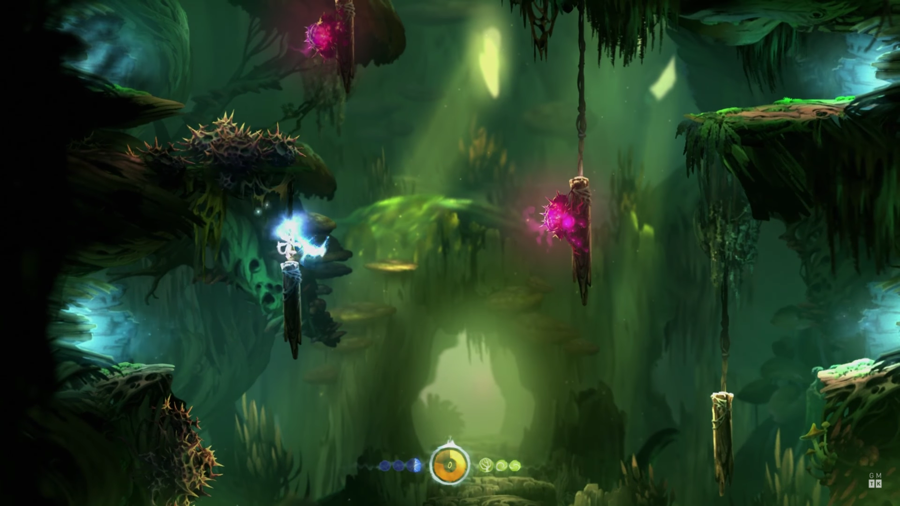

**Movement**

* double jump
* wall jump
* **bash - the game’s signature move**
* glide

**Attack**

* spirit flame attack